Gevangen snoeken HSV De Breuly 2024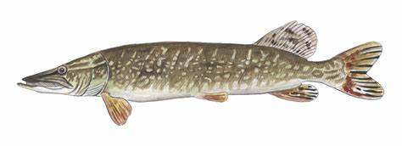

*Snoek: “Esox lucius”*

|  |  |  |  |  |
| --- | --- | --- | --- | --- |
| Datum | Water | Lengte | Gewicht | Bijzonderheden * |
|  |  |  |  |  |
|  |  |  |  |  |
|  |  |  |  |  |
|  |  |  |  |  |
|  |  |  |  |  |
|  |  |  |  |  |
|  |  |  |  |  |
|  |  |  |  |  |
|  |  |  |  |  |
|  |  |  |  |  |
|  |  |  |  |  |
|  |  |  |  |  |
|  |  |  |  |  |
|  |  |  |  |  |
|  |  |  |  |  |
|  |  |  |  |  |
|  |  |  |  |  |
|  |  |  |  |  |
|  |  |  |  |  |
|  |  |  |  |  |
|  |  |  |  |  |
|  |  |  |  |  |
|  |  |  |  |  |
|  |  |  |  |  |
|  |  |  |  |  |

*Bijvoorbeeld: kunstaas/dood visje/ diepte/ temperatuur/ etc.